## JACK SENSE代码流程

1. **主动事件注册**

hdac_bus.c

snd_hdac_bus_init() {

//注册主动事件

INIT_WORK(&bus->unsol_work,snd_hdac_bus_process_unsol_events);

}

snd_hdac_bus_process_unsol_events()

{

    while (bus->unsol_rp != bus->unsol_wp) {

        if (drv->unsol_event)

            drv->unsol_event(codec, res);

    }

}

patch_conexant.c

static const struct hda_codec_ops cx_auto_patch_ops = {

    .unsol_event = snd_hda_jack_unsol_event,

};

hda_jack.c

void snd_hda_jack_unsol_event()

{

    call_jack_callback(codec, res, event);

    snd_hda_jack_report_sync(codec);

}

1. **主动事件回调处理函数**

hda_generic.h

回调函数实现：

/* standard jack event callbacks */

void snd_hda_gen_hp_automute(struct hda_codec *codec,

struct hda_jack_callback *jack); //耳机自动静音

void snd_hda_gen_line_automute(struct hda_codec *codec,

struct hda_jack_callback *jack); //外放自动静音

void snd_hda_gen_mic_autoswitch(struct hda_codec *codec,

  struct hda_jack_callback *jack); //MIC自动切换

回调函数注册：

check_auto_mute_availability(codec);//耳机和外放自动静音回调函数注册

check_auto_mic_availability(codec); //MIC自动切换回调函数注册

1. **主动事件调用**

hda_controller.c

Codec芯片JSense管脚产生中断，调用如下函数：

irqreturn_t azx_interrupt(int irq, void *dev_id){

snd_hdac_bus_update_rirb(bus);  //接受RIRB条目

}

snd_hdac_bus_update_rirb()

{

  snd_hdac_bus_queue_event(bus, res, res_ex);

}

snd_hdac_bus_queue_event()

{

  schedule_work(&bus->unsol_work);    //处理主动事件

}

1. **JSense中断产生**

芯片电路实现：

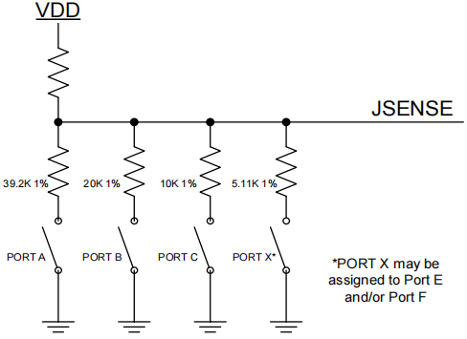

AFG中定义的主动上报消息源，当源状态改变时，芯片主动上报消息：

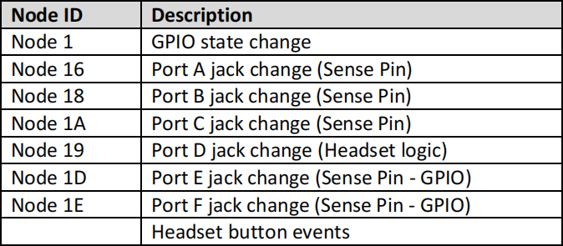

1. **中断分析**

插拔耳机孔，查看中断trace信息如下：

root@E490-2:/sys/kernel/debug/tracing# cat trace

# tracer: nop

#

# entries-in-buffer/entries-written: 2/2   #P:8

#

#                                _-----=> irqs-off

#                               / _----=> need-resched

#                              | / _---=> hardirq/softirq

#                              || / _--=> preempt-depth

#                              ||| /     delay

#           TASK-PID     CPU#  ||||   TIMESTAMP  FUNCTION

#              | |         |   ||||      |         |

          <idle>-0       [007] d.h. 60822.084078: hda_unsol_event: [0000:00:1f.3:0] res=0x04000000, res_ex=0x00000010

          <idle>-0       [007] d.h. 60822.624109: hda_unsol_event: [0000:00:1f.3:0] res=0x08000000, res_ex=0x00000010

（1）00:1f.3表示音频PCI设备

root@E490-2:/sys/kernel/debug/tracing# lspci

00:1f.3 Audio device: Intel Corporation Cannon Point-LP High Definition Audio Controller (rev 30)

1. 参数res解析

根据HDA 7.3.3.14 Unsolicited Response章节，res右移26位表示tag。即0x04000000对应的tag为1，0x08000000对应的tag为2。查看如下codec信息，即可得知，分别对应codec的0x16和0x19。

root@E490-2:/# cat /proc/asound/card0/codec#0

Node 0x16 [Pin Complex] wcaps 0x400581: Stereo

  Pincap 0x0001001c: OUT HP EAPD Detect

  EAPD 0x2: EAPD

  Pin Default 0x03211040: [Jack] HP Out at Ext Left

    Conn = 1/8, Color = Black

    DefAssociation = 0x4, Sequence = 0x0

  Pin-ctls: 0xc0: OUT HP

  Unsolicited: tag=01, enabled=1

  Power states:  D0 D1 D2 D3 EPSS

  Power: setting=D0, actual=D0

  Connection: 2

     0x10* 0x11

Node 0x19 [Pin Complex] wcaps 0x40048b: Stereo Amp-In

  Control: name="Mic Boost Volume", index=0, device=0

    ControlAmp: chs=3, dir=In, idx=0, ofs=0

  Amp-In caps: ofs=0x00, nsteps=0x03, stepsize=0x2f, mute=0

  Amp-In vals:  [0x00 0x00]

  Pincap 0x00001324: IN Detect

    Vref caps: HIZ 50 80

  Pin Default 0x03a11030: [Jack] Mic at Ext Left

    Conn = 1/8, Color = Black

    DefAssociation = 0x3, Sequence = 0x0

  Pin-ctls: 0x24: IN VREF_80

  Unsolicited: tag=02, enabled=1

  Power states:  D0 D1 D2 D3 EPSS

  Power: setting=D0, actual=D0

1. 结论：插拔耳机孔，JSENSE管脚产生中断，CODEC向controller发送0x16和0x19的主动上报事件。